21.12.2023
Measuring complete stack, with coax probe, MWR and MRD probed on VABO:
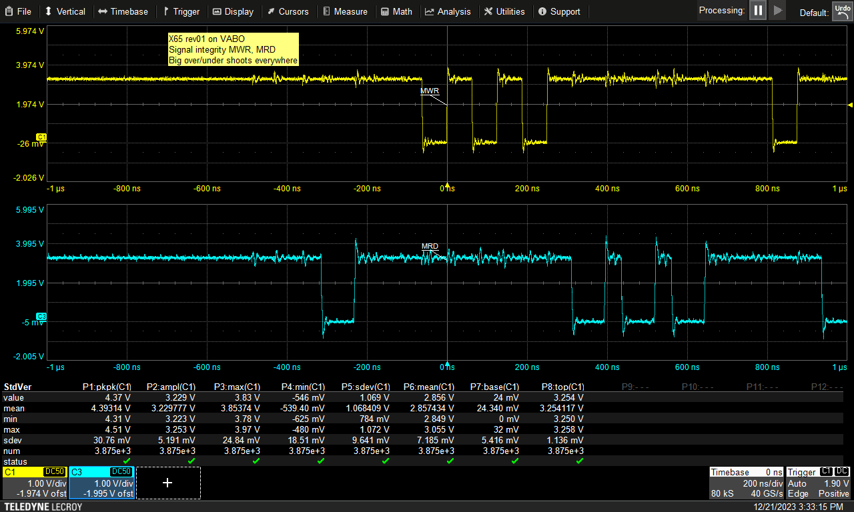

Edge speed is quite high:
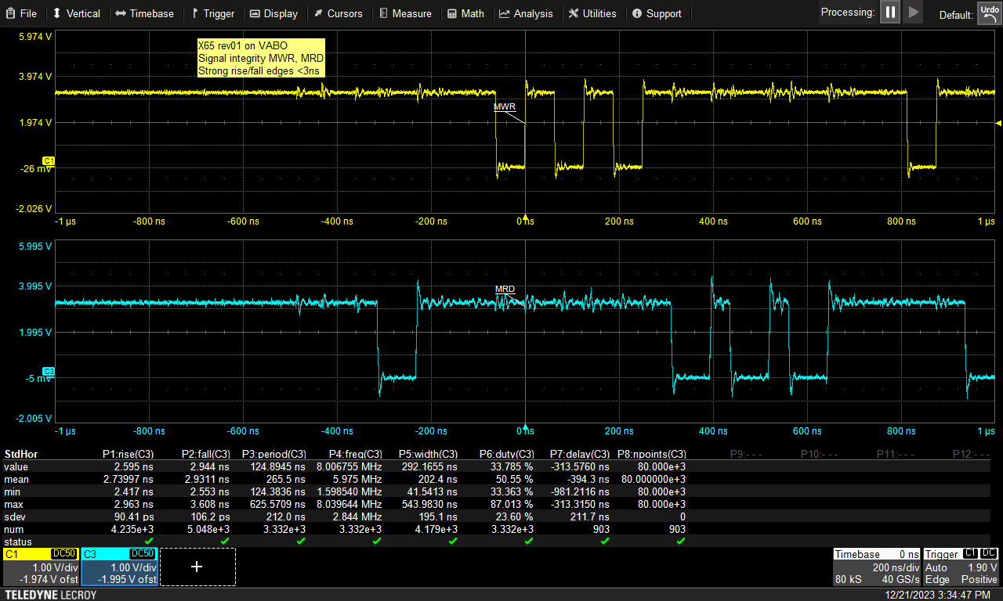

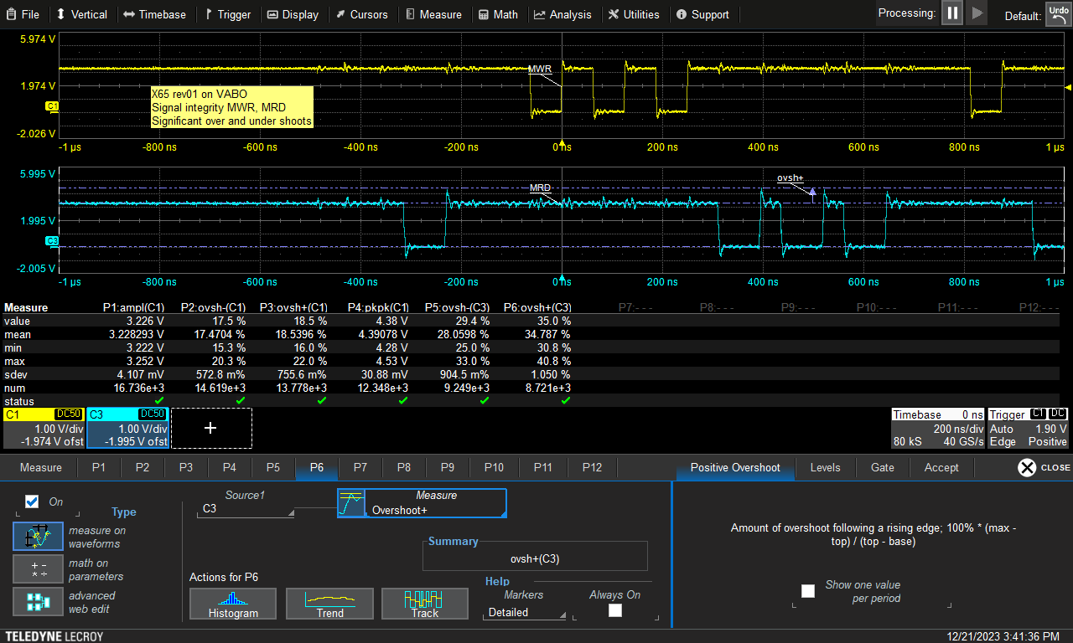

Without VABO – less loading → much bigger overshoots!
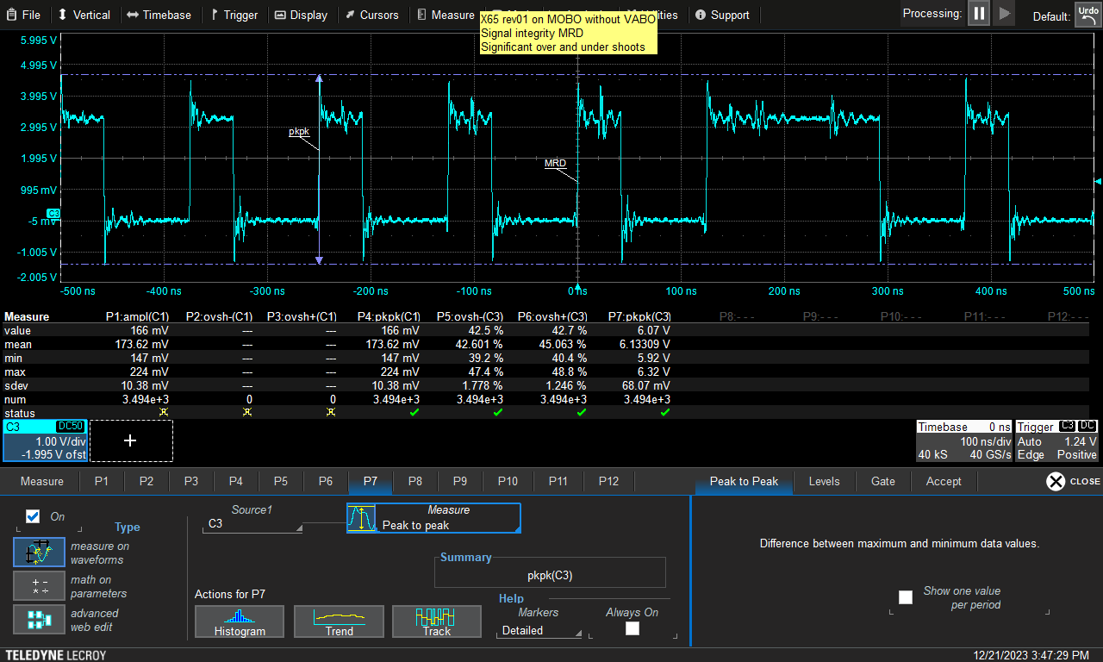

In detail:
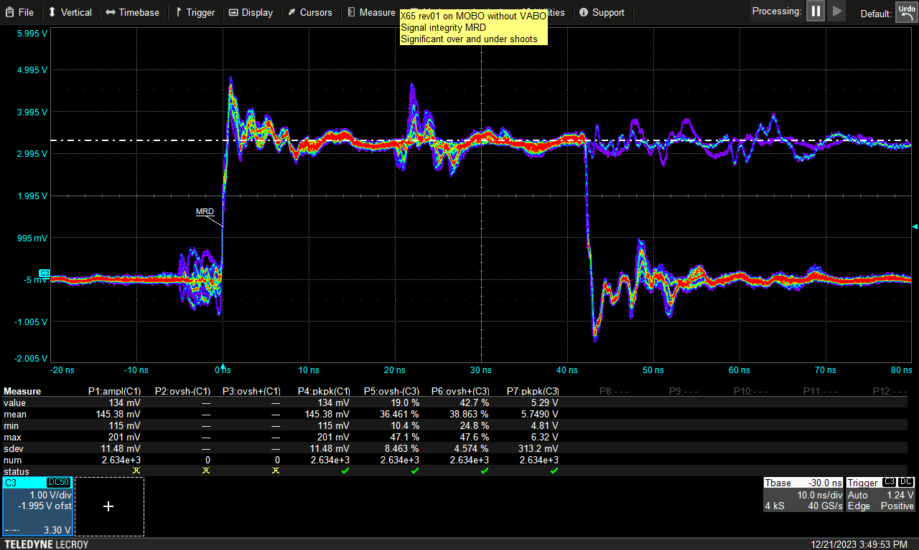

Rising edge in detail:

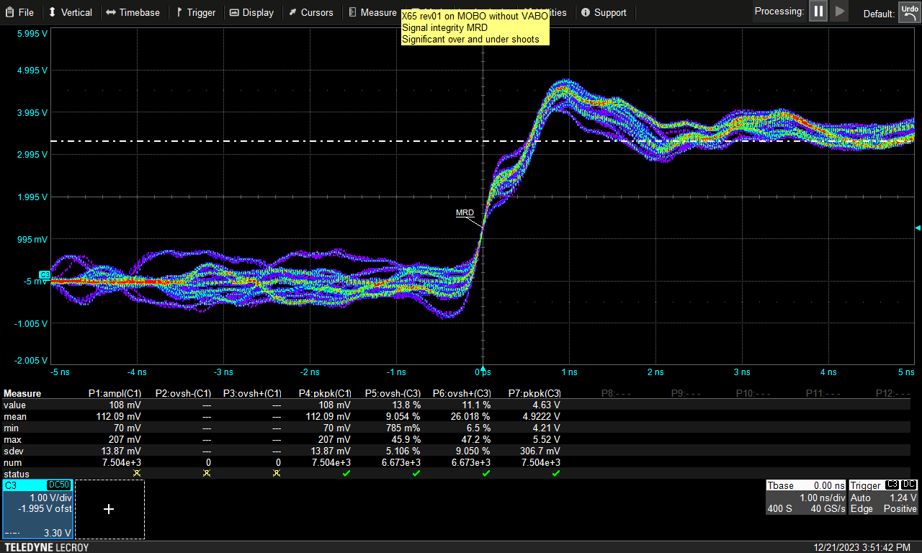

Same rising edge but with VABO loaded:

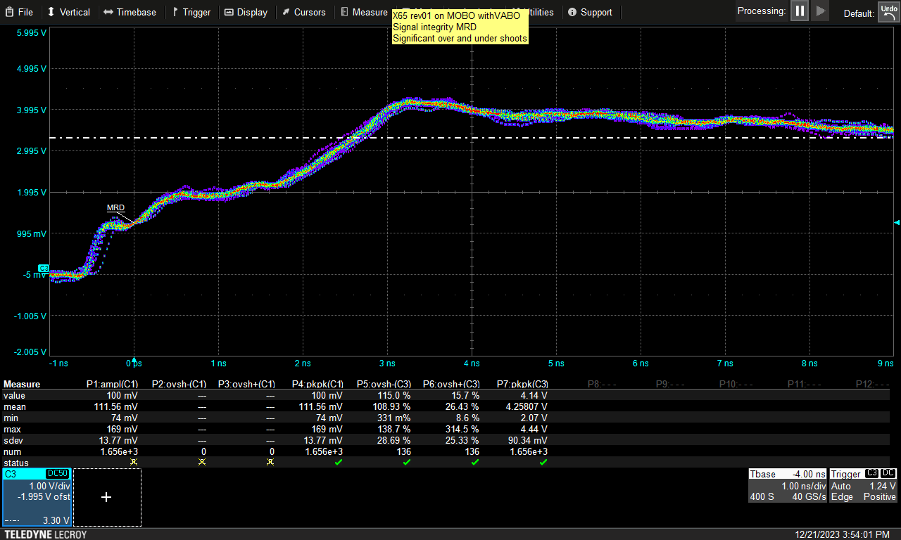

22.12.2023
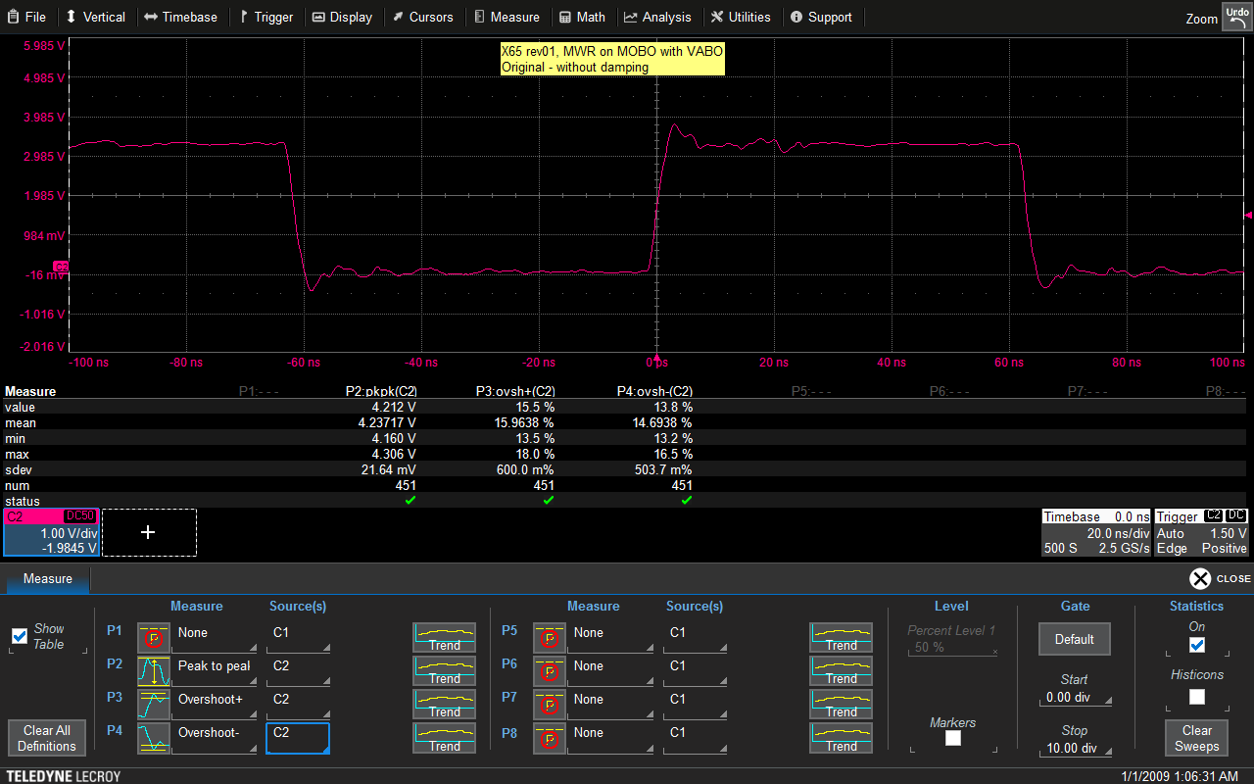

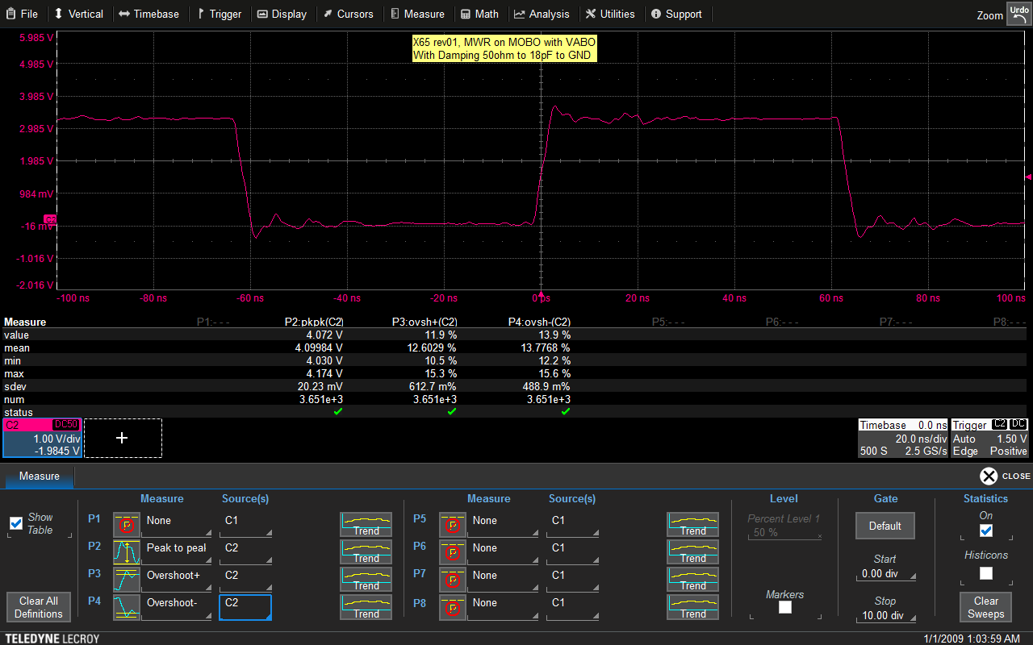

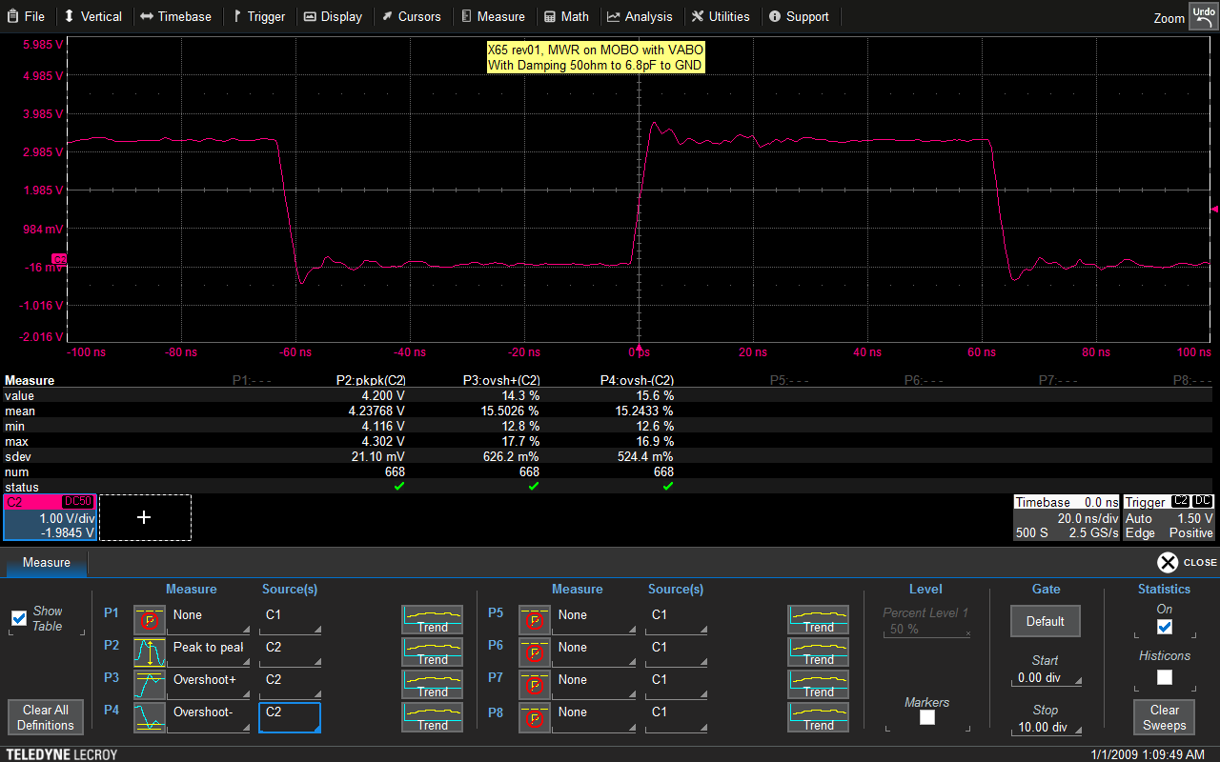

Damping network 50ohm+(7 to 18pF) does not help significantly!! (few percent points overshoot)
- Just better layout / 4 layer board could solve it !!??

